**RESUME**

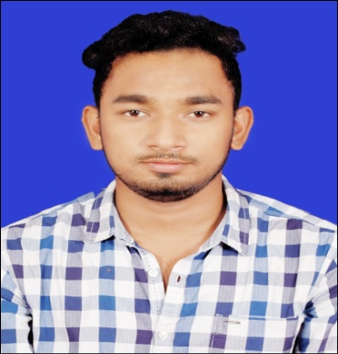**AtulPradhan**

**Mobile : +91-8018676454**

**Email-id:atul.pradhan123@gmail.com**

**Address:Deepali Cineplex road,hatpada,bargarh**

**Career Objective :**

To secure a growth-oriented position that will allow the conversion of academic knowledge to professional expertise and to allow the matching of my personal goals to that of the organization’s objectives in a challenging and competitive environment.

**Educational Qualification** :

|  |  |  |  |
| --- | --- | --- | --- |
| **COURSE** | **SCHOOL/COLLEGE NAME** | **YEAR OF PASSING** | **PERCENTAGE OF MARKS** |
| **HSCE** | **S.A.I.I.E.R., Bargarh** | **2010** | **85** |
| **CHSE** | **VIKASH JUNIOR COLLEGE, Bargarh** | **2012** | **86** |
| **B.COM** | **BJB AUTONOMOUS COLLEGE, Bhubaneswar** | **2015** | **52** |
| **MBA** | **RCEM, Bhubaneswar** | **2017** | **68** |

**Work Experience** :

|  |  |  |  |
| --- | --- | --- | --- |
| **Organisation** | **Joining date** | **Designation** | **Years completed** |
| **Utkal Builders Ltd.** | **15/03/2019** | **Liaising department** | **1** |

**Seminar Attended:**

Finance Is the life blood impact of globalization in Indian economy.

**Core Strength :**

* Workaholic, dedicated, dependable on my work.
* Comprehensive problem solving ability and willingness to learn.
* Goal oriented, highly focused & self-motivated who excel in high pressure situation.
* Maintain punctuality in every step of life.

**Computer Skills:**

* MS-Excel
* MS-Word
* Ms-Power Point
* PGDCA

**Hobbies:**

* Travelling to New places and Net surfing
* Listening to Music

**Personal Details**

Father’s Name :Prabala Kumar pradhan

Mother’s Name :Basantipradhan

Gender :Male

Date of Birth :21st April 1995

Marital Status :Unmarried

Languages Known:English, Hindi, Odia

Permanent Address : Bargarh

**Declaration :**

I, hereby declare that the aforesaid information is true to the best of my knowledge and belief.

Date : 24/09/2020 Atul kumarPradhan

Place: BHUBANESWAR